**Report on Essay competition**

On 7th August 2024, Government Degree College Kupwara organized an intra-college Essay Competition on the theme “The Unsung Heroes of Freedom Struggle and 77 years of Independence” in the Conference Hall. The competition was organized by Debates & Seminar Committee under the patronage of Principal of the College Prof. (Dr.) Abdul Rasheed Malik. The main aim of the event was to raise awareness among the students about the freedom struggle of India and inculcate a sense of oneness and pride in one’s nation. It was also intended to select most talented student to compete in a District level inter-college competition. A good number of students of various semesters of the college participated in the competition. The evaluators for the essay competition were Dr. Mohammad Ashraf Bhat (HOD English), Dr. Khalid Bashir Malik (HOD History) and Prof. Mohmad Abass Bhat, HOD Environmental Science. The toppers of the competition shall be felicitated with trophies and certificates later in an event to be held on the Independence Day (15th August, 2024), the first three positions were achieved by Mr. Zakir Hussain Ganie, Faizan Altaf Shah AND Insha Hameed.

Speaking on the occasion, Prof. (Dr.) Ab. Rashid Malik gave an overview of the supreme sacrifices made by the countrymen for the freedom of the country. He advised the students to actively take part in such activities and play their role towards the progress and development of the country. The program concluded with the vote of thanks presented by Prof. Nasir Sunaullah (HOD Arabic). The program was moderated by Dr. Mohammad Yousuf Wani (Convener Debate/ Seminar committee). A large number of staff members and students participated in the program.

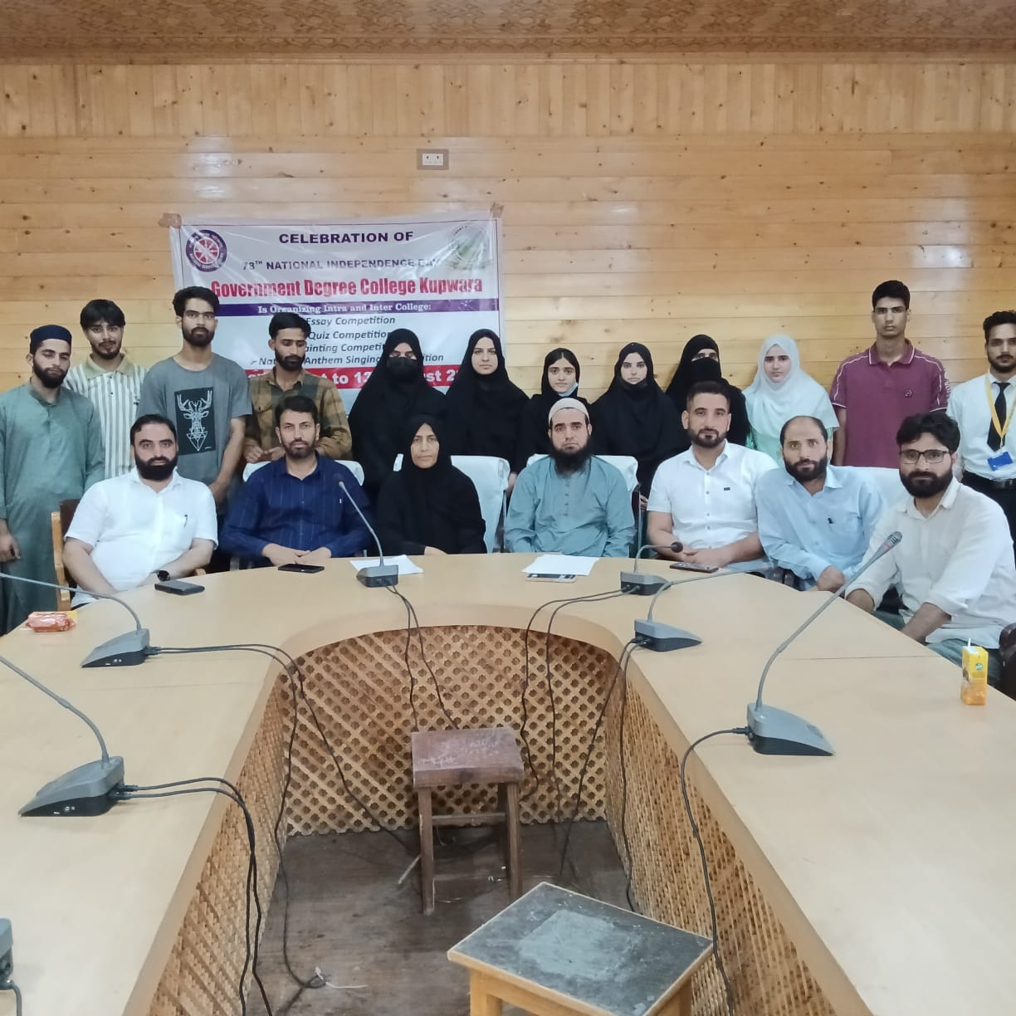

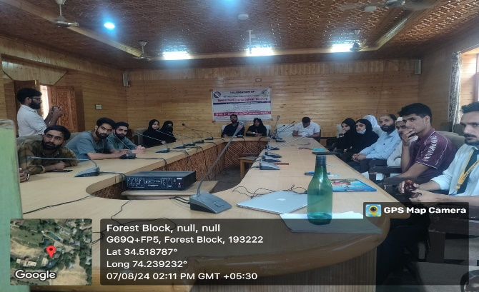 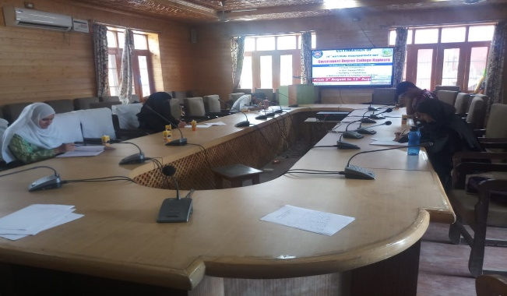

**Convenor Debate/Seminar Committee Principal**