**Report on Quiz Competition**

On 7th August 2024, Government Degree College Kupwara organized an intra-college Quiz Competition on the theme “Covering Freedom Struggle and National Heroes” in the Conference Hall. The competition was jointly organized by Debates & Seminar Committee and Cultural Committee under the patronage of Principal of the College *Prof. (Dr.) Abdul Rasheed Malik”.* The main aim of the event was to raise awareness among the students with regard to the freedom struggle of India and its heroes. *Dr. Nasir Sonaullah,* Head of the Department of Arabic, briefed the participants about the modalities, including the time limit, total rounds for the quiz, and the marks each question carried. The event was moderated by Dr. M. Yousf Wani; HoD Urdu. *Prof Nuzhat Jabeen;* HoD Botany, *Dr. Mohamad Ashraf;* HoD English and *Dr. Mohmad Abass Baba;* HoD Environmental Science were the Scorers for the competition. At the outset *Dr. Khalid Bashir;* HoD Department of History spoke about the theme and gave a general overview of the freedom struggle and the heroes who sacrificed mainly for the freedom of the country. Then he acted as Quiz master and regulated the whole session. The results were declared by *Dr. M. Ashraf Bhat.* The event was attended by a good number of staff members and students.

Group ‘A’ comprising of two students namely *Shariq Ghani Lone* and *Amir Ahmad Dar* bagged 1st position, while as Group ‘B’ consisting of two students namely *Shariq Zahoor* and *Tanveer Ahmad* emerged as runner up group.

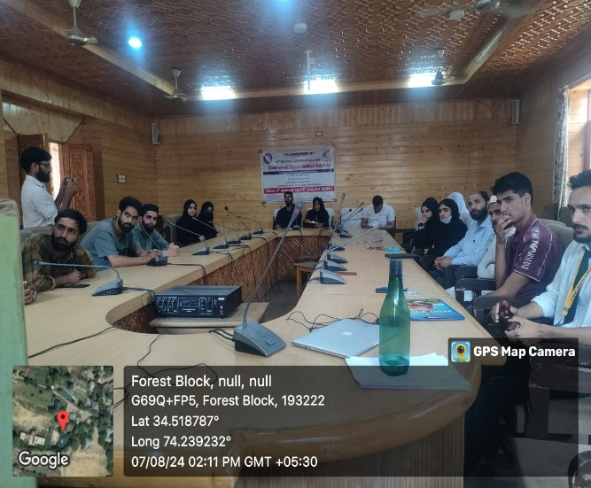 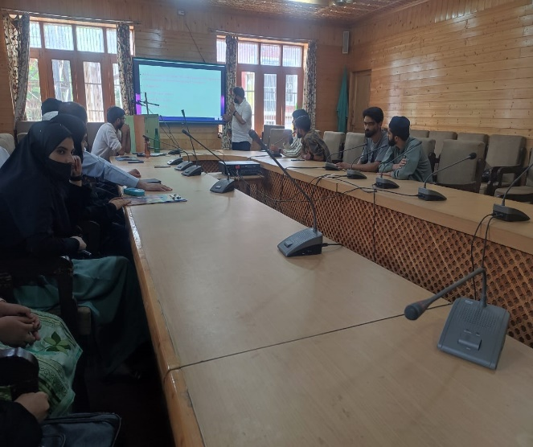

**Convenor Debate/ Seminar Committee Principal**